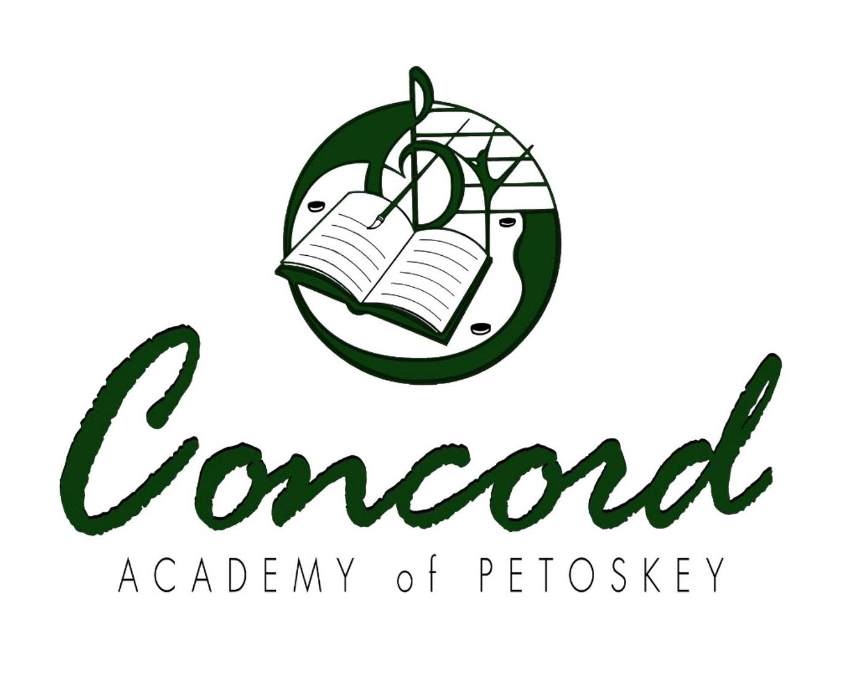

CONCORD ACADEMY PETOSKEY

BOARD MEETING DATE CHANGE

THE REGULAR CONCORD ACADEMY PETOSKEY SCHOOL BOARD OF DIRECTORS MEETING PREVIOUSLY SCHEDULED FOR MAY 15TH HAS BEEN RESCHEDULED FOR MAY 14TH AT 5:30PM AT THE CONCORD ACADEMY PETOSKEY SCHOOL IN THE BAND ROOM. THIS IS AN OPEN MEETING; THE PUBLIC IS WELCOME. FOR MORE INFORMATION, PLEASE CONTACT THE EXECUTIVE DIRECTOR AT 231-439-6800.

FOR MORE INFORMATION, PLEASE CONTACT THE EXECUTIVE DIRECTOR AT 231-439-6800. Posted 4/29/25 LAC

Any person with a disability who needs accommodation to participate in a meeting should contact the Director of the Academy at 231-439-6800 at least 5 (five) days in advance of the meeting to request assistance.
Official minutes available: Minutes of all Concord Academy Petoskey Board meetings are available at the Academy.

